March 1, 2018

Dear Guidance Counselor:

I would like to inform you of a scholarship opportunity for high school seniors. In 2007, the High Plains Chapter of the American Meteorological Society (AMS) and the National Weather Association (NWA) established the Jim Johnson scholarship. The AMS and NWA are professional organizations, their mission being to support and promote excellence in meteorology and related fields. The High Plains chapter represents members in western Kansas, as well as western and central Nebraska. Jim was one of the instrumental people who helped start the chapter in 1996. His weather career spanned several decades, first with the U.S. Air Force and then with the National Weather Service. Jim retired as a National Weather Service Lead Forecaster from the Dodge City, Kansas office in September, 2006.

Our chapter annually awards a $500 scholarship to a high school senior that will be pursuing a career in one of the physical sciences (e.g. Chemistry, Physics, Astronomy, as well as Earth Sciences including geology, hydrology, meteorology, oceanography, and soil science). The scholarship is also open to those going into the teaching profession in the physical sciences. The student must be currently attending a high school in the forecast and warning area of one of the following National Weather Service Offices; Dodge City and Goodland, Kansas, and North Platte and Hastings, Nebraska. If this letter was sent to your school, your students are eligible to apply. Specifics of the scholarship application process are listed below.

(1) Applicant will provide proof of acceptance to a college with a physical science major.
(2) Applicant will write a one page essay stating what they plan to do in the physical sciences
once they receive their degree…and how it will contribute to their discipline.
(3) The format of the essay should be 12 point font, double spaced.
(4) Application deadline is April 20, 2018.
(5) Scholarship will be awarded by May 1, 2018.
(6) Scholarship is non-renewable.

Applications should be sent to:

Mike Reed
6365 Osborne Drive West
Hastings, Nebraska 68901-9163

If you have any questions, please contact me by email at: michael.reed@noaa.gov

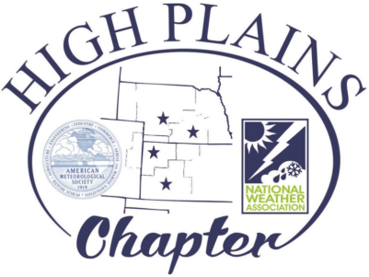
Sincerely,

Mike Reed
Committee Member for the Jim Johnson Scholarship

